### Title Banner with VA seal and text reading: VA US Department of Veterans Affairs

**VA.gov Sign-In Experience**

Version 1

Launch: October 31, 2024

# Table of Contents

Overview

User Access

Navigation

Paths for each link within the sign-in modal

Common Errors

Additional Resources

# Overview

The Sign-in Experience on VA.gov encompasses the end-to-end process of user authentication. We have designed this product area to enable Veterans to quickly and intuitively access essential VA benefits and services. We aim to introduce features and capabilities to guide users through critical points in the sign-in process. Sign-in Experience includes ownership of the Unified Sign-in Page (USiP) and sign-in modal, which offer multiple options for securely accessing VA.gov applications, including Login.gov, ID.me, MyHealtheVet (MHV), and DS Logon.

Two of these options will be made unavailable in 2025. MyHealtheVet will be available through January 31, 2025. DS Logon will be available through September 30, 2025.

# User Access

Users will encounter the Sign-in Experience as the first step toward accessing their personal information and services on VA.gov. This page is open to all users; no prior sign-in is required to see or use the available sign-in options.

* **Login.gov and ID.me**: Recommended options that provide secure, modern credential access to VA.gov services.
* **DS Logon and MHV**: Alternative options for users with existing accounts using these services are available. Both are being deprecated in 2025.

The Sign-in Experience is designed to be user-friendly, allowing users to select their sign-in method and gain access to their VA benefits and services via VA.gov. The goal is to ensure users can access all necessary information quickly and securely.

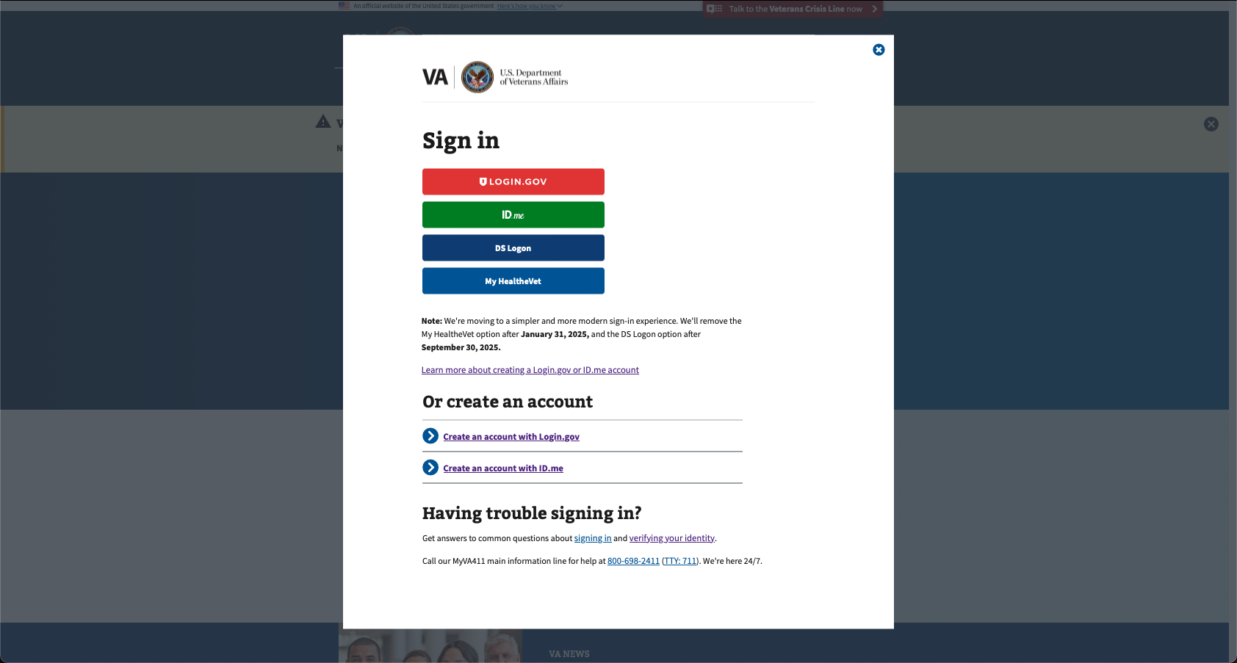

*Fig. 1: The current VA.gov sign-in modal.*

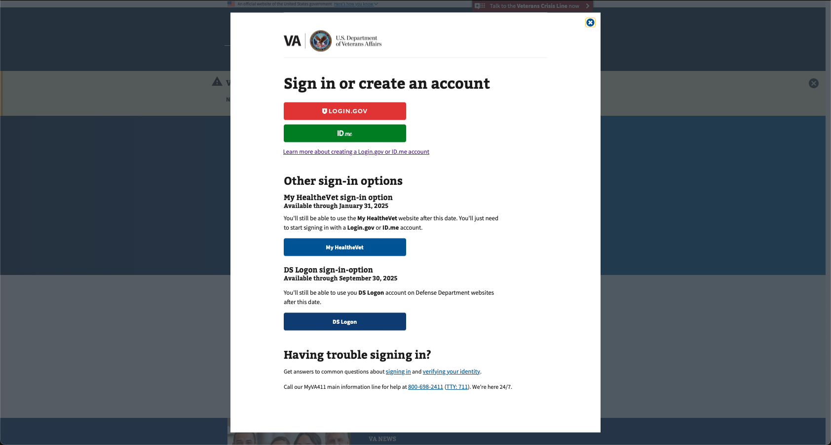

*Fig. 2: The updated VA.gov sign-in modal will alert users of the upcoming MyHealtheVet and DS Logon changes.*

Navigation

## The following are paths for each link within the sign-in modal:

| **Element** | **Description** | **Link** |
| --- | --- | --- |
|  | Login.gov is a secure sign-in service the public uses to sign in to participating government agencies. Login.gov is provided by Technology Transformation Services (TTS). | <https://secure.login.gov/> |
|  | ID.me is an online identity network. Users can verify their identity with ID.me once and seamlessly sign in across websites without creating a new sign-in or verifying their identity again. | <https://api.id.me/en/session/new> |
|  | My HealtheVet is a Credential Service Provider (CSP) and VA's Personal Health Record for Veterans, service members, their caregivers, and others. Available through February 1, 2025. | <https://mhvidp-prod.myhealth.va.gov/mhv-portal-web/web/guest/home?p_p_state=maximized&p_p_mode=view&saveLastPath=false&_58_struts_action=%2Flogin%2Flogin&p_p_id=58&p_p_lifecycle=0&_58_redirect=%2Fmhv-portal-web%2Fc%2Fportal%2Fsaml%2Fsso> |
|  | DS Logon is a Credential Service Provider (CSP) hosted in the Defense Manpower Data Center (DMDC).Available through September 30, 2025. | <https://myaccess.dmdc.osd.mil/identitymanagement/app/login> |
|  | Learn more about account creation. | <https://www.va.gov/resources/creating-an-account-for-vagov/> |
|  | Create an account with Login.gov. | <https://secure.login.gov/> |
|  | Create an account with ID.me. | <https://api.id.me/en/session/new> |
|  | Links to a help article about signing in. | <https://www.va.gov/resources/signing-in-to-vagov/> |
|  | Links to a help article about verifying your identity. | <https://www.va.gov/resources/verifying-your-identity-on-vagov/> |

# Common Errors

Although there are no technical changes that should cause additional errors, the following table catalogs errors Veterans might encounter when attempting to authenticate when signing in to their accounts. We have provided a detailed list of common errors and their potential causes to help you troubleshoot any issues you may encounter during the sign-in process.

Additional context can be found at [Login Errors](https://github.com/department-of-veterans-affairs/va.gov-team/blob/master/products/identity/login/error-messages/sign-in-error-handling.md).

| **Error Code** | **Title** | **URL with more details** |
| --- | --- | --- |
| 001 | Authorization denied by user | [Error 001](https://github.com/department-of-veterans-affairs/va.gov-team/blob/master/products/identity/Troubleshooting_logging/Authentication_Errors/001.md) |
| 002 | The user is auto-logged out after signing in (incorrect system time). | [Error 002](https://dev.va.gov/auth/login/callback/?auth=fail&code=002) |
| 003 | API server time is incorrect | [Error 003](https://dev.va.gov/auth/login/callback/?auth=fail&code=003) |
| 004 | MPI mismatch | [Error 004](https://dev.va.gov/auth/login/callback/?auth=fail&code=004) |
| 005 | Session expired | [Error 005](https://dev.va.gov/auth/login/callback/?auth=fail&code=005) |
| 007 | Default/unknown error | [Error 007](https://dev.va.gov/auth/login/callback/?auth=fail&code=007) |
| 009 | Failure to proof (Login.gov) | [Error 009](https://dev.va.gov/auth/login/callback/?auth=fail&code=009) |
| 101 | Multiple MHV IDs (MHV IENs) | [Error 101](https://dev.va.gov/auth/login/callback/?auth=fail&code=101) |
| 102 | Multiple EDIPIs | [Error 102](https://dev.va.gov/auth/login/callback/?auth=fail&code=102) |
| 103 | ICN mismatch | [Error 103](https://dev.va.gov/auth/login/callback/?auth=fail&code=103) |
| 104 | UUID missing | [Error 104](https://dev.va.gov/auth/login/callback/?auth=fail&code=104) |
| 106 | Multiple Corp IDs | [Error 106](https://dev.va.gov/auth/login/callback/?auth=fail&code=106) |
| 108 | MHV verification error | [Error 108](https://dev.va.gov/auth/login/callback/?auth=fail&code=108) |
| 110 | Terms of use—Provisioning failure (Oracle Health) | [Error 110](https://dev.va.gov/auth/login/callback/?auth=fail&code=110) |
| 111 | Terms of use—User not eligible (Oracle Health) | [Error 111](https://dev.va.gov/auth/login/callback/?auth=fail&code=111) |
| 112 | Terms of use—Provisioning failure (MHV) | [Error 112](https://dev.va.gov/auth/login/callback/?auth=fail&code=112) |
| 201 | Default/unknown OAuth error | [Error 201](https://dev.va.gov/auth/login/callback/?auth=fail&code=201) |
| 202 | State mismatch (OAuth) | [Error 202](https://dev.va.gov/auth/login/callback/?auth=fail&code=202) |
| 203 | Invalid request (OAuth) | [Error 203](https://dev.va.gov/auth/login/callback/?auth=fail&code=203) |

# 

# **Additional Resources**

* Account Creation
  + [How to create a Login.gov account](https://www.va.gov/resources/how-to-create-a-logingov-account-for-va/)
  + [How to create an ID.me account](https://www.va.gov/resources/how-to-create-an-idme-account-for-va/)
* [Step-by-step signing in](https://www.va.gov/resources/signing-in-to-vagov/)
* [What is account verification, and why is it important?](https://www.va.gov/resources/what-does-it-mean-to-verify-my-identity-and-why-do-i-have-to-do-it/)
  + [How to verify your Login.gov account](https://www.va.gov/resources/how-to-verify-your-identity-for-your-logingov-account/)
  + [How to verify your ID.me account](https://www.va.gov/resources/how-to-verify-your-identity-for-your-idme-account/)
* [Various levels of account verification](https://github.com/department-of-veterans-affairs/va.gov-team/tree/master/products/identity#understanding-verified-identity)
  + [NIST guidelines on identity proofing](https://nvlpubs.nist.gov/nistpubs/SpecialPublications/NIST.SP.800-63a.pdf)